Ecology Study Guide Name _________________________________Date______Per___

1. All the robins in an area would be an example of a(n):
A. community B. population C. ecosystem D. biosphere

2. The broadest, most inclusive level of ecological organization is the
A. population B. community C. biosphere D. ecosystem

3. A pond is an example of a(n)
A. population B. community C. biosphere D. ecosystem

4. Ecologists use models to
A. make predictions about the future behavior of an ecosystem
B. substitute for observations from the natural world
C. increase the complexity of simple ecosystems
D. account for the influence of every variable in a real environment

5. Which of the following is the correct order of lease to most inclusive ecological organization?
A. organism → community → population → ecosystem → biosphere
B. community → organism → population → ecosystem → biosphere
C. population → organism → ecosystem → community → biosphere
D. organism → population → community → ecosystem → biosphere

6. One biotic factor that could influence a plant might be
A. the amount of sunlight B. soil pH C. CO₂ concentration D. a pollinating insect

7. The role a species plays in its environment is called the species’
A. habitat B. niche C. resources D. survivorship curve

8. An animal that feeds on leaves from only a few species of plants is an example of a
A. specialist B. generalist C. regulator D. conformer

9. A detritivore is an organism that

A. feeds on both producers and consumers.
B. feeds on the “garbage” of an ecosystem
C. converts biomass into “garbage” in an ecosystem
D. produces carbohydrates by using energy from inorganic molecules

10. An organism’s position in the sequence of energy transfers in an ecosystem is known as its
A. trophic level B. energy level C. net productivity D. feeding location

11. The percentage of energy transferred from on level to another in a food chain is usually
A. greater than 90% B. about 75% C. about 50% D. less than 20%

12. Compared to the lowest trophic level, the highest trophic level contains
A. more individuals B. less energy C. more producers D. fewer carnivores

13. The exponential model of population growth applies

A. when there are no limiting factors
B. if the birth rate increases as the population grows
C. when the population size exceeds the carrying capacity
D. to all real populations that exist in nature

14. The logistic model of population growth

A. reflects the fact that the carrying capacity fluctuates with environmental changes
B. does not accommodate the influence of limiting factors
C. reflects the fact that the birth rate decreases as the population grows
D. applies to all real populations that exists in nature

15. A country may have a negative growth rate if its

A. population is mostly young people
B. birth rate is higher than its death rate
C. death rate is higher than its birth rate
D. population has access to health care

16. One difference between predators and parasites is that parasites
A. usually do not cause the immediate death of the organism on which they feed
B. feed only on the inside of other organisms
C. are always microorganisms
D. are not anatomically or physiologically specialized

Short Answer
1. Describe the stages of primary succession and compare primary succession and secondary succession.

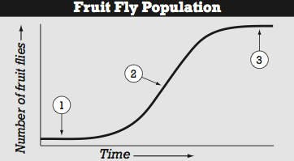
2. Describe the curve to the right, and explain what is happening at each of the numbered steps. What is the name of step 3?

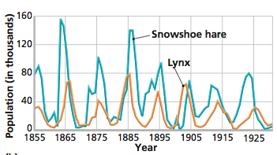
3. Describe the Predator-Prey Cycle and use the graph of lynx and hare populations to help your explanation.

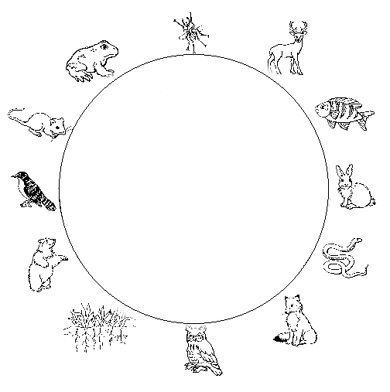
4. Draw arrows to complete the food web below:

