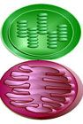
Energy for Life Outline Name ____________________________Date_____Per___
(Photosynthesis and Respiration)

I. Introduction to Photosynthesis
- Compare autotrophs and heterotrophs.

- What does photosynthesis do?

- Write the equation for photosynthesis.

II. Leaf Structure
- What is the function of the stomata?

- What is transpiration?

- What organelle is responsible for the light reactions of photosynthesis?

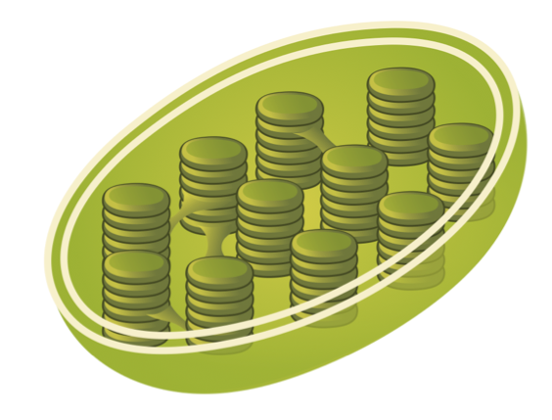
III. Leaf Pigments and Light (electromagnetic radiation)
- What is the purpose of thylakoid discs and stroma? (label)

- Why are most leaves green?

- What is the benefit of carotenoids?

4. On the wave below, label the crest and wavelength λ

Define:
Crest:
Wavelength:
Frequency:

5. What are the colors of the visible spectrum?

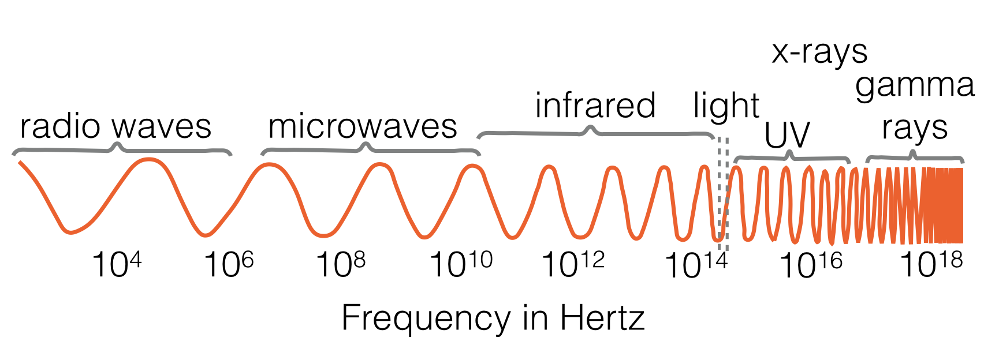

6. Energy: Energy:
Wavelength: Wavelength:
Frequency: Frequency:

7. What does light do to electrons in atoms?

8. When an electron “falls” from an excited state to the ground state, what could happen? Label.
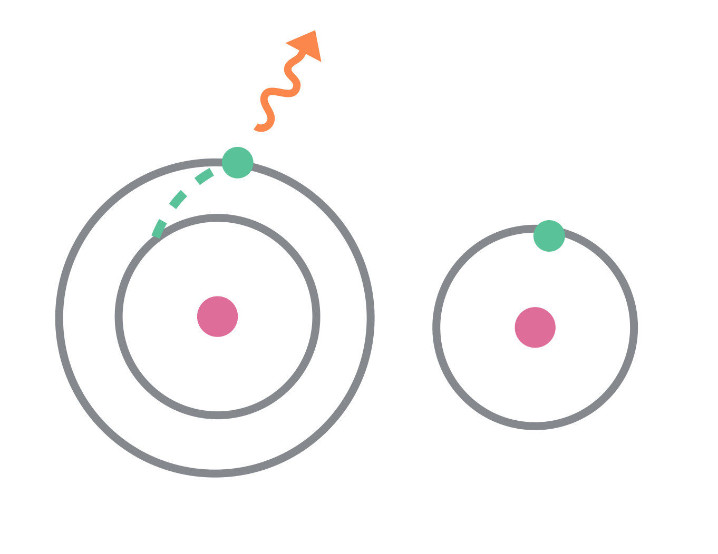

-

-

+
+

IV. Carbohydrates
- Organic compounds always have what element in them? What is the exception?

- What are the three main categories of carbohydrates?

- Give examples of mono-, di- and poly- saccharides.
  - Monosaccharides:

  - Disaccharides:

  - Polysaccharides:
- What type of carbohydrate is indigestible by humans and is known as “fiber” or “roughage”?

V. Photosynthesis Steps and Pathways
- What is another name for the light reaction?

- The captured light excites _________________________ which are transferred from one molecule to the next by the ___________________ ____________________ ______________.
An enzyme then splits a ________________ molecule releasing ______________ which diffuses out of the plant. The ______________________ that are produced are left in the thylakoid.
_______________________, the main energy currency of cells is made using the protons from the water molecules with the enzyme ______ ___________.

- What is the Calvin Cycle?

- _____________________ from the atmosphere are fixed into organic compounds.
- What is the Calvin cycle sometimes called?

- Why is this maybe not the best name for this process?

- What kind of carbon compounds are made by C4 plants?

- Why is the CAM pathway necessary for cactuses?

VI. Cellular Respiration
- What is cellular respiration?

- How are cellular respiration and photosynthesis related?

- What is the difference between the terms aerobic and anaerobic?

- Write the chemical equation for cellular respiration.
VII. Cellular Respiration Steps and Pathways
- What molecule is glucose broken down into during glycolysis?

- What is fermentation?

- Where and when does lactic acid fermentation happen in your body?

- How does bread making depend on alcoholic fermentation?

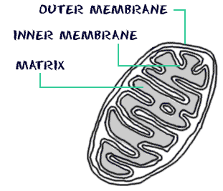
- In which organelle does aerobic cellular respiration take place in eukaryotic cells?

- The two parts of aerobic respiration are the ________________ cycle and the
____________________ ________________________ _______________________.

- What gas is released during the Kreb’s cycle?

- In which part of the mitochondria does the electron transport chain take place?

- How many ATP are produced by each of these reactions:

Glycolysis

Kreb’s Cycle

Electron Transport Chain

VIII. Photosynthesis and Respiration in Action
- Energy from the sun is locked into what during photosynthesis?

- Energy in the bonds of glucose are converted into ATP during what process?

- Ultimately, photosynthesis and respiration convert sunlight into what?

