Genetics Outline Name__________________________Date______Per___
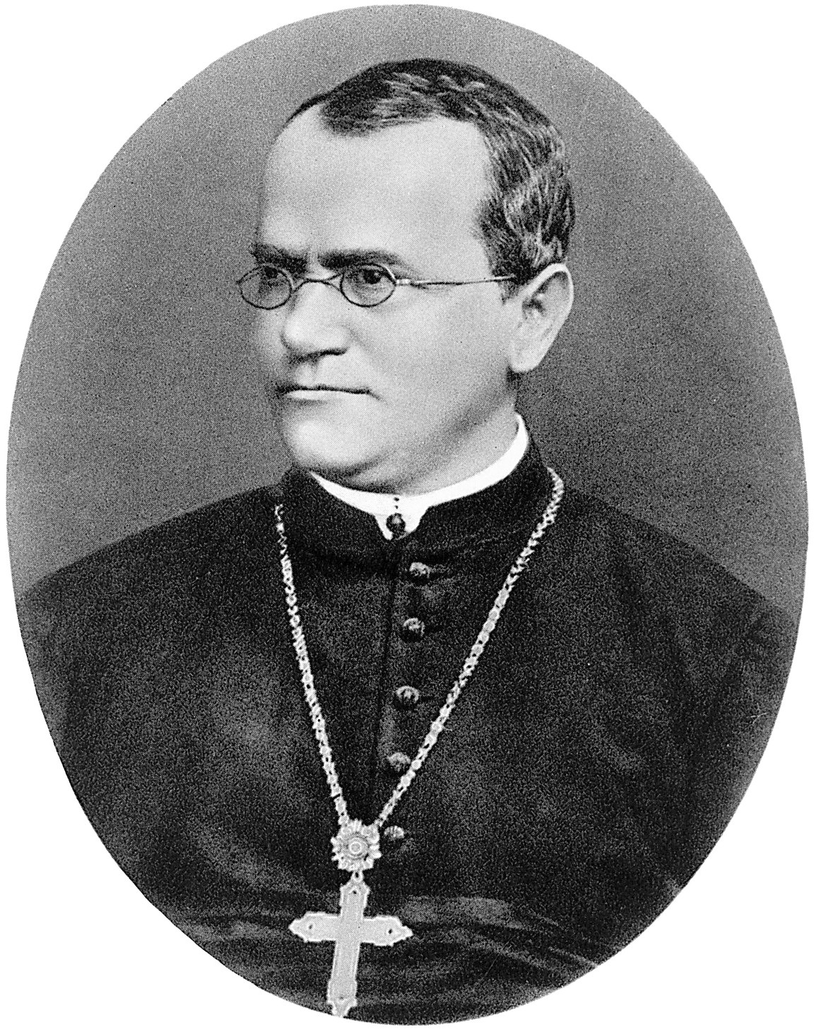
- Gregor Mendel – Father of genetics
  - Who was Gregor Mendel and what did he study?

  - Mendel noticed that traits seemed to “disappear” in certain generations. He later coined the terms “dominant” and “recessive” to help explain this. How do these terms explain the temporary disappearance of traits?

  - What is an F1 generation? An F2 generation?

  - How does capitalization of letters symbolize dominant and recessive traits?

  - What is the difference between a gene and an allele?

  - What does heterozygous mean? Homozygous dominant? Homozygous recessive?

  - Green (G) is the dominant color for pods of pea plants. Yellow (g) is recessive. What are the phenotypes of the following allele pairs (genotypes)?
GG = Gg= gg =
  - Assuming tallness is dominant, what would the genotype look like for a man who is homozygous for tall? What are the possible gamete combinations?

  - What would the genotype look like for a woman who is heterozygous for tall? What are the possible gamete combinations?

- Monohybrid crosses
  - What is a monohybrid cross?

  - What is the difference between genotypic ratio and phenotypic ratio?

  - If a homozygous tall man and a heterozygous tall woman were to have a child, what are the possible genotypic and phenotypic ratios?

  - What is the difference between autosomal dominant and autosomal recessive traits?

  - Huntington’s disease is an autosomal dominant disease that affects the nervous system. The symptoms of the disease do not appear until the person is middle-aged. If a woman’s father had the disease, what would the probability of her having the disease be? Is it likely that the father was homozygous dominant?

  - Cystic Fibrosis is an autosomal recessive disease resulting in the body’s production of excess mucous. What would the probability be for a couple who is heterozygous for the trait to have a child who is affected?

  - How do you make a Punnett square to determine the probability of having a boy or a girl?

  - A family has four daughters. What is the probability that a fifth child would be female?

  - Use a Punnett square to determine the possible genotypes of the F1 generation when a heterozygous black rabbit is crossed with a homozygous brown (bb) rabbit.

  - White (W) hair is dominant over black (w) hair in sheep. A white male and a black female are parents of a black lamb. What is the probability that their next lamb will be white?

  - The offspring of two short-tailed cats have a 25% chance of having no tail, a 25% chance of having a long tail, and a 50% change of having a short tail. What can you hypothesize based on this information about the genotypes of the parents?

- Non-Mendelian genetics
  - Incomplete dominance
    - What is incomplete dominance?
    - The genes for flower color in Japanese four o’clocks show incomplete dominance. Give the genotypic and phenotypic ratios of flower colors for the following crosses (RR= red, Rr = pink, rr = white)
      - Pink x pink

      - White x red

  - Co-dominance
    - What is co-dominance?

    - A homozygous red horse is mated with a roan horse (codominant red and white hairs), what is the possibility of producing another roan horse?

    - What is the chance of a female with blood type A and a male with type B blood to have a child with blood type O?

  - Sex-linked traits
    - What is a sex-linked (X-linked) trait?

    - A normal male (X^{H}Y) and a female (X^{H}X^{h}) who is a carrier of hemophilia marry. What is the probability of a child produced by these two individuals being born with the disease?

    - A man that is red-green colorblind (X^{n}Y) has a child with a woman (X^{N}X^{N}) that does not carry the colorblind gene. What is the probability that a child born from this union is colorblind?

    - Eye color is a sex-linked trait in Drosophila. Red eyes are dominant over white eyes. Use a Punnett square to determine the possible genotypes and phenotypes of a cross between a white-eyed female and a red-eyed male.

- Dihybrid crosses, test crosses and probability
  - Test Cross
    - What is a test cross?

    - Straight wings are dominant over curly wings in fruit flies. How would you determine whether a straight-winged fly is heterozygous or homozygous?

  - Dihybrid cross
    - How many traits are tested at a time with a Dihybrid cross?

    - What gamete combinations are possible when the following groups of alleles separate in meiosis?
AABB AABb AaBb Aabb

    - Black (B) hair is dominant over brown (b) hair in rabbits. Short (H) hair is dominant over long (h) hair. If a homozygous black short-haired rabbit is crossed with a homozygous brown long-haired rabbit, what would be the genotype and phenotypes of the F1 generation?

      - List the genotypic and phenotypic ratios for the F2 offspring produced between crosses of two animals of the F1 generation.

    - A yellow guinea pig is crossed with a white guinea pig. All of the offspring are cream-colored. The cream-colored animals are crossed. 16 yellow, 33 cream, and 15 white animals are born.
      - Explain these results.

      - Explain how a white breed could be developed by starting with two cream colored parents. Draw a Punnett square to illustrate your explanation.

  - Epistasis
    - What is epistasis?

    - What ratio occurs with a heterozygous Dihybrid cross where epistasis is present?

  - Polygenic Traits
    - What is a polygenic trait?

  - Probability
    - What is the probability product rule?

    - If peas that are heterozygous for both tall stems and green seed pods are crossed, the probability is that 75% of the offspring will be tall. The probability is also that 75% of the offspring will have green seed pods. What is the percentage of the offspring that are likely to be tall and have green seed pods?

    - Use the probability product rule to determine the following:
      - The probability that both parents will be carriers of Cystic Fibrosis, when the incidence of carriers among the general population is 1/20

      - The risk of a couple having a child with Cystic Fibrosis when, in order to have the disease, the child must be homozygous recessive for the trait. Explain your answer.

- Pedigrees
  - Label the pedigree below:
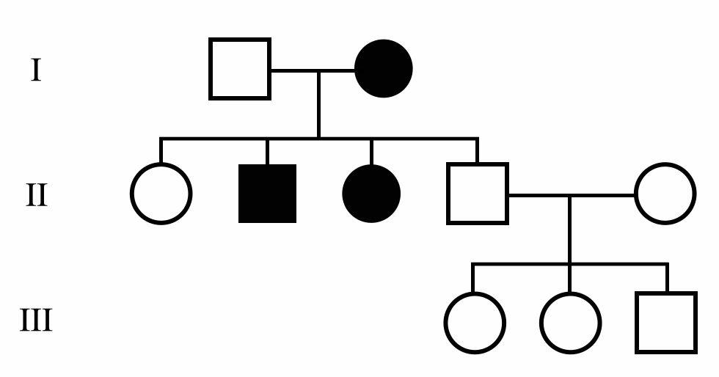

  - How can you tell if a trait is autosomal dominant?

  - How can you tell if a trait is autosomal recessive?

  - How can you tell if a trait is X-linked?

