Labels and Functions Name_______________________________Date_______Per____

Digestive System
Feature | Function | Label
Masseter Muscle |  | 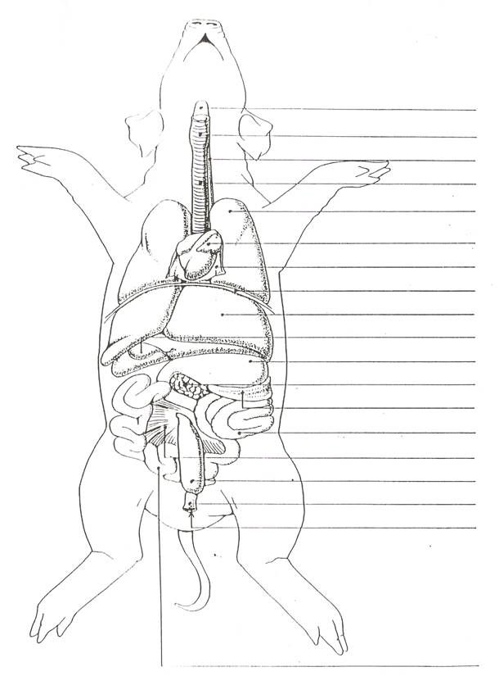  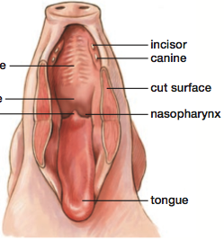
Salivary Glands
Pharynx*
Papillae (taste buds)
Soft Palate*
Hard Palate*
Esophagus*
Liver*
Small Intestine
Large Intestine (colon)*
Cecum
Gall Bladder*
Pancreas*
Stomach*
Mesentery*
Rectum*
Anus*

Respiratory System
Feature | Function | Label
Diaphragm*
Trachea*
Larynx*
Epiglottis
Pharynx*
Lungs*

Urogenital (Reproductive and Excretory)
Feature | Function | Label
Kidneys* |  | 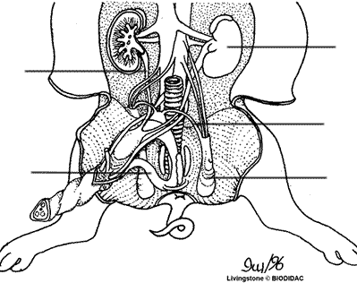
Ureter*
Urinary Bladder*
Urethra

Male Reproductive System
Feature | Function | Label
Scrotal Sacs
Testis*
Epididymis*
Vas Deferens*
Penis*

Female Reproductive System
Feature | Function | Label
Ovaries* |  | 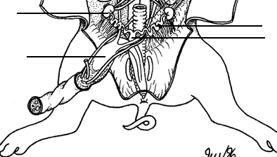
Oviduct*
Uterus*
Vagina

Circulatory System
Feature | Function | Label
Atria* |  | 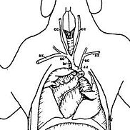
Ventricles*
Pericardium
Common Carotid*
Jugular
Umbilical Vessels

Miscellaneous Systems
Feature | Function | Label
Thyroid* |  | 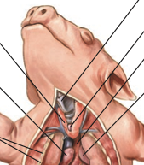
Spleen
Nipples

