Meiosis Study Guide Name_______________________________Date________Per___

1. What is the purpose of meiosis?

2. Name 2 types of cells that are haploid ___________ and _____________.

3. Fill in the blanks with the best word or phrase using the word bank to the right. (all words may not be used)

During Interphase before Meiosis, the DNA is _________________. During Prophase I, __________________ chromosomes pair up as tetrads and undergo the process called __________________________. During this process, segments of chromosomes from mom are exchanged with similar segments of chromosomes from dad. This process of synapsis and crossing over leads to genetic ______________________ in the offspring. During Metaphase I, the homologous pairs orient themselves along the metaphase plate (middle of the cell) _________________________ to each other. This random orientation of homologues is another major reason
Word Bank
Synapsis
Crossing over
Recombination
Homologous chromosomes
Spindle
Spindle fibers
Sister chromatid
Different
Replicated
Homologous
Next
8388608
Nuclear membrane
2
Haploid
Diploid

for genetic variation in offspring. With 23 pairs of chromosomes, the human cells have 2 to the power of 23 or ____________________ ways to orient themselves along the metaphase plate.
During Anaphase I, the _________________________________ ________________ separate and each one is pulled by _______________ fibers to the opposite poles of the cell. During Telophase I, the ________________ __________________ forms around the separated chromosomes and the cell will have ________ nuclei at opposite poles, each containing 1 homologous set of chromosomes. Cytokinesis will pinch the cytoplasm in the middle, leading to 2 daughter cells with a ______________ number or 23 chromosomes each.
During Meiosis II, the __________ ___________ will attach to the centromere of each chromosomes to line them up in the middle of the cell. During Anaphase II, the spindle fibers will shorten and pull apart the ______________ __________ of each duplicated chromosome to opposite poles of the cell. By the end of Meiosis II, there will be 4 daughter cells which are genetically ________________ from each other.

Diagram a pair of homologous chromosomes undergoing synapsis and then crossing over. Explain what is occurring with the chromosomes.

Study the diagram below and complete the following sentences.
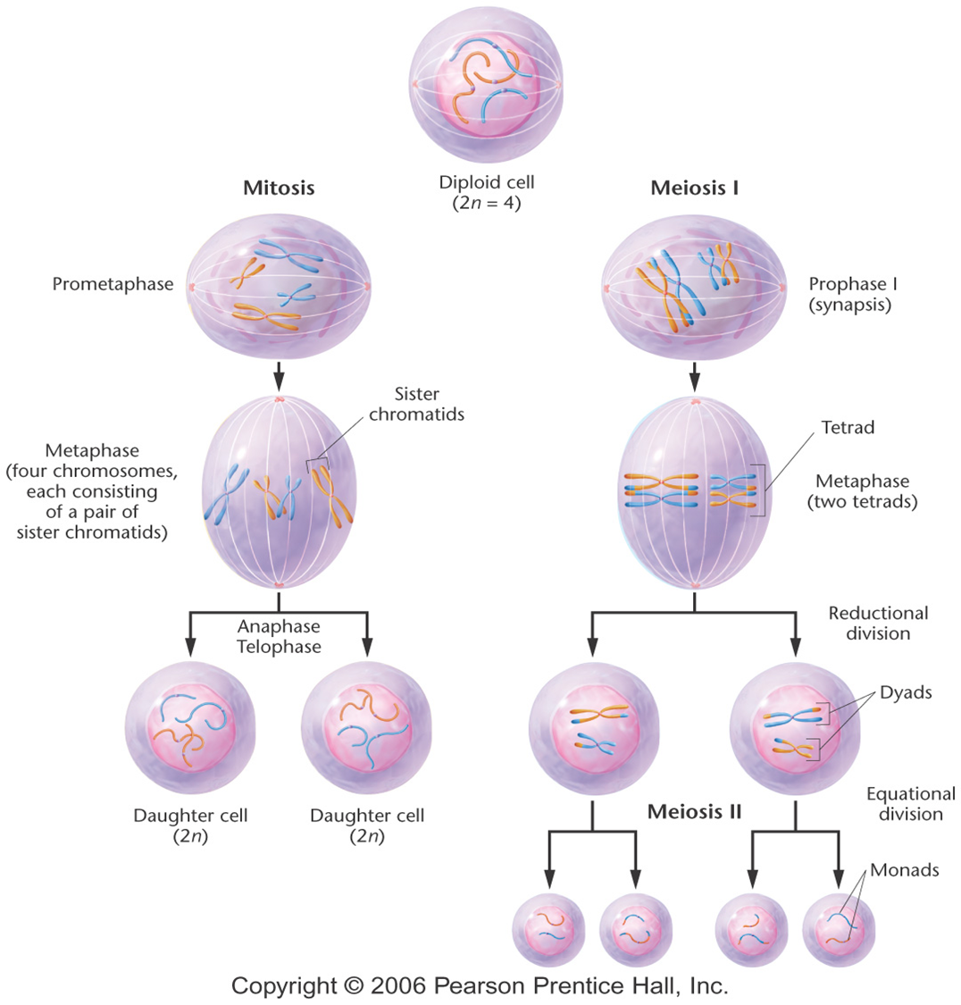

Mitosis begins with a single _____________ (2n) cell and results in ___________________________________ cells.

Meiosis I begins wih a single _____________ (2n) cell and results in __________________________________ cells. Meiosis 11 is technically a ________________________division during which the sister chromatids in the two haploid cells _________________. Meiosis results in a total of __________ ________________ cells.

Are all the gametes (egg or sperm cells ) produced by one individual the same? Explain, giving 2 reasons based on Meiosis.

What occurs during fertilization?

Is the resulting zygote/embryo haploid or diploid. Explain.
For each of the following statements about Meiosis (and the Cell Cycle for Meiosis) determine the specific phase in which the events described in each statement occur.

- Sister chromatids move to opposite poles of the cell. ______________________
- Homologous chromosomes align in the center of the cell. _____________________
- DNA replication occurs. ______________________
- Tetrads are formed. _________________________
- Homologous chromosomes move to opposite poles of the cell. _____________________
- Four daughter cells are formed. ______________________
- Crossing over occurs. _____________________
- Two daughter cells are formed. __________________

Use the following chart to describe the differences between mitosis and meiosis.

Characteristics | Mitosis | Meiosis
Goal or function

Creates what sort of cells?
Somatic or sex cells?
Creates genetically-(different/identical cells)

Number of divisions

No. of daugter cells;
diploid 2n or haploid n ?

Pairing of homologous chromosomes
(Yes/No)

Crossing over (Yes/No)

