Photosynthesis and Respiration Name__________________________Date_______Per_____
Practice Quiz

- Another name for the light reaction is the light ______________ reaction.

- Photosystems are clusters of light-absorbing pigments located on the _______________ _________ of the chloroplast.

- The energy currency of cells is a molecule called ________________ ________________ or ______ for short.

- The energy carrier molecule or “taxi cab” picks up hydrogen and 2 electrons and carries them into the __________to be used in the dark reaction. This molecule is called ___________ when it has picked up hydrogen and 2e-.

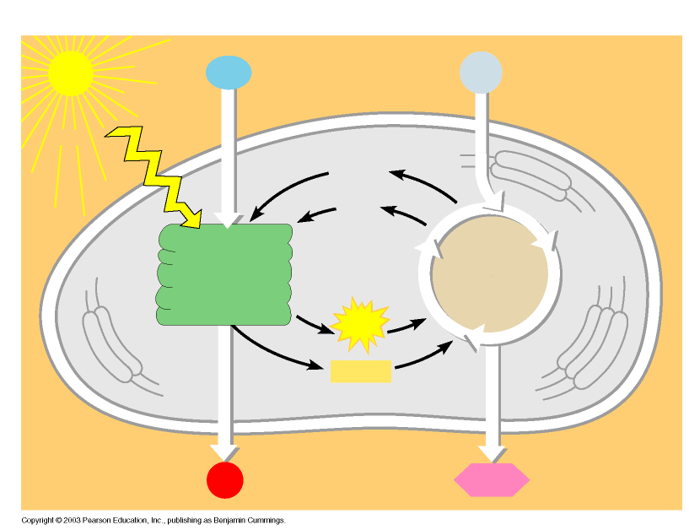
- How many turns of the light reaction are needed to make one oxygen molecule?___________
- The dark reaction is also known as the light ________________ reaction or the Calvin Cycle.

- Carbon dioxide is split into two parts, and after 6 turns of the Calvin Cycle, produces ___(#) sugar and ____(#)waters.

- CAM plants conserve water by doing the light reaction during _______ time, keeping stomata ________, and the dark reaction during ___________ time when they can ________ the stomata.

- Fill in the blanks on the diagram to the right:

- The goal of cellular respiration is to convert glucose into
A. glycogen B. fructose C. ATP D. sucrose

11. Aerobic respiration is different from anaerobic respiration because aerobic respiration uses
A. glucose B. carbon dioxide C. ATP D. oxygen

12. Write the basic equation for respiration:
___________________________________→___________________________________________

13. Glycolysis breaks down ______________ molecules into two _____________ acids and two net energy molecules of ______.

14. Anaerobic respiration in yeast produces two products, which are ___________ and _________________. This process is called _____________________ ________________________.

15. How many ATP are made TOTAL in aerobic respiration?_____________

16. How many ATP come from the electron transport chain/chemiosmosis?______________

17. In which step of aerobic respiration is oxygen used? _________________________________

