The Cell Name ____________________________________Per____
Biology Outline

I. Cell history, microscopes and characteristics of life
A. What is a cell?

B. What important discoveries were made by the following scientists?
i. Robert Hooke

ii. Anton van Leeuwenhoek

iii. Robert Brown
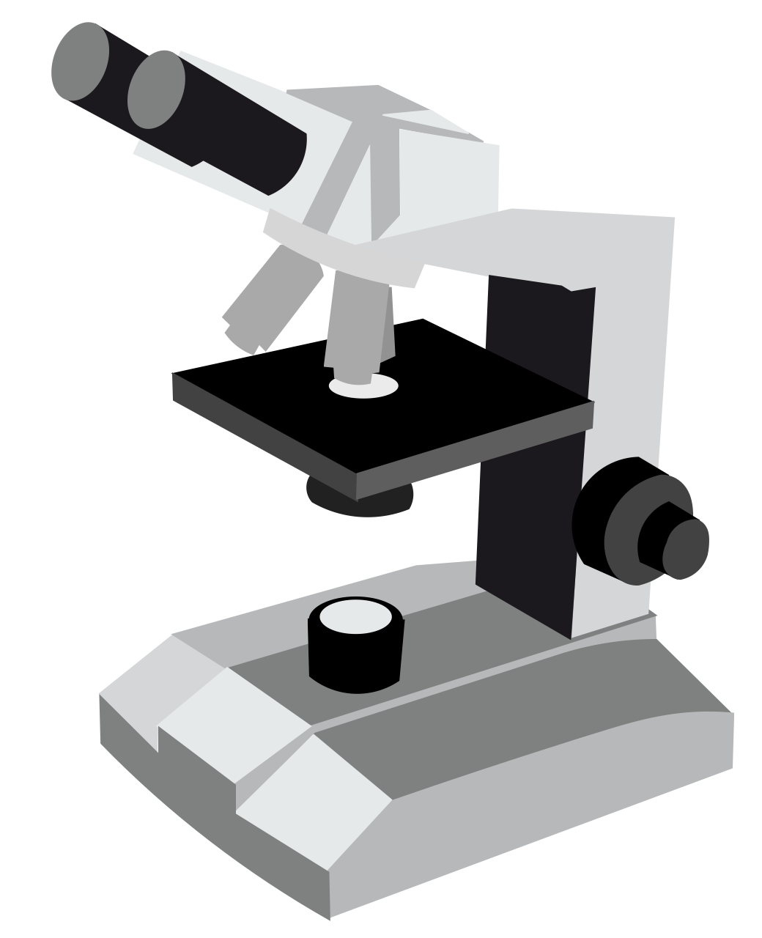
C. What are the three parts of the cell theory?

D. What invention fueled developments in cell biology?

E. Label the major parts of the microscope.

F. What are the seven characteristics of life?

II. Cell Diversity, Shape and Basic Cell Parts
A. Diversity, shape and size
i. What is cell diversity?

ii. What is cell shape dependent on?

iii. How are cells limited in size? Why do cells need to be so small?

B. Basic Cell Structure
i. What 3 things do all cells have?

ii. What are the functions of the plasma (cell) membrane?

iii. What is in the nucleus/nuclear region?
iv. What is the cytoplasm? How is cytosol different from cytoplasm?

C. Two types of cells
i. How are prokaryotes and eukaryotes different?

ii. Give an example of a prokaryote and a few examples of a eukaryote.

D. Cellular Organization
i. What is a colony of cells? Why aren’t they considered one organism?

ii. What are the levels of organization (divisions of labor) for a multicellular organism?

III. Parts of the Eukaryotic Cell
A. Lipids
i. phospholipids

ii. triglycerides

iii. waxes

iv. sterols

B. Cell membrane
i. Describe the phospholipid bilayer and label the parts. (Phospholipid bilayer letter____)

ii. Which part is polar/hydrophilic and which part is nonpolar/hydrophobic?

iii. What other type of lipid can be found in the cell membrane? (Letter ____)

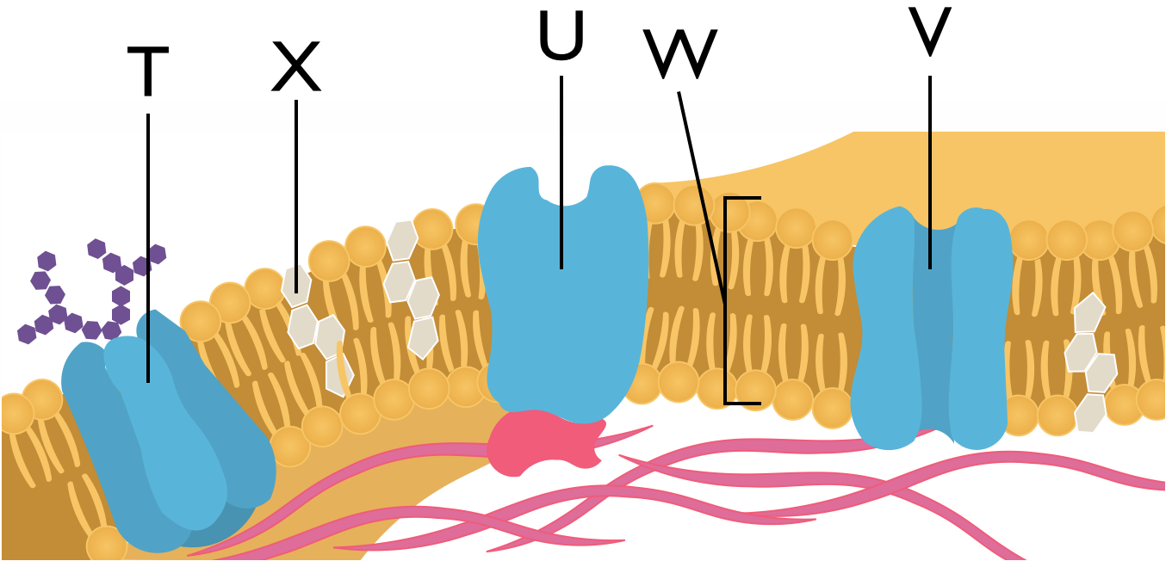
iv. Describe the three main types of membrane proteins:

v. Where are peripheral and integral proteins positioned in the cell membrane?

vi. Why do scientists use the phrase “fluid-mosaic model” to describe the cell membrane?

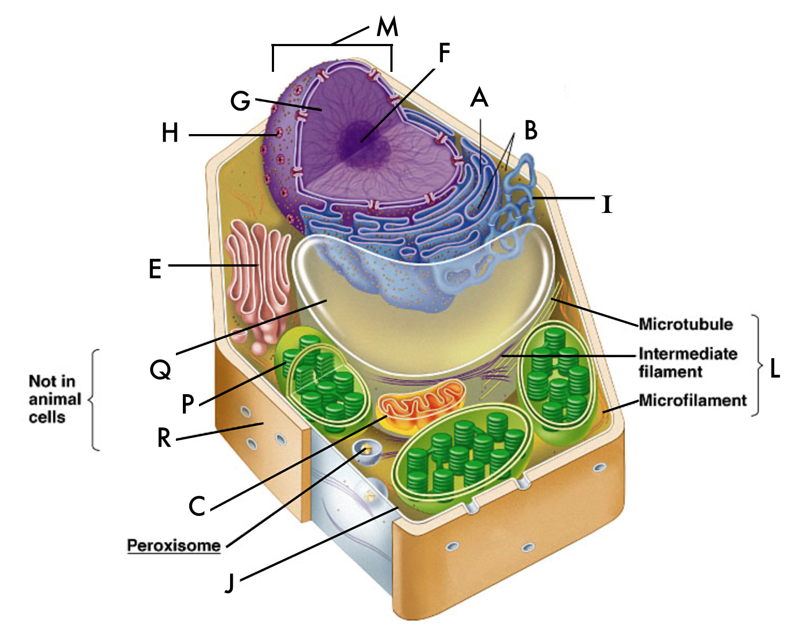
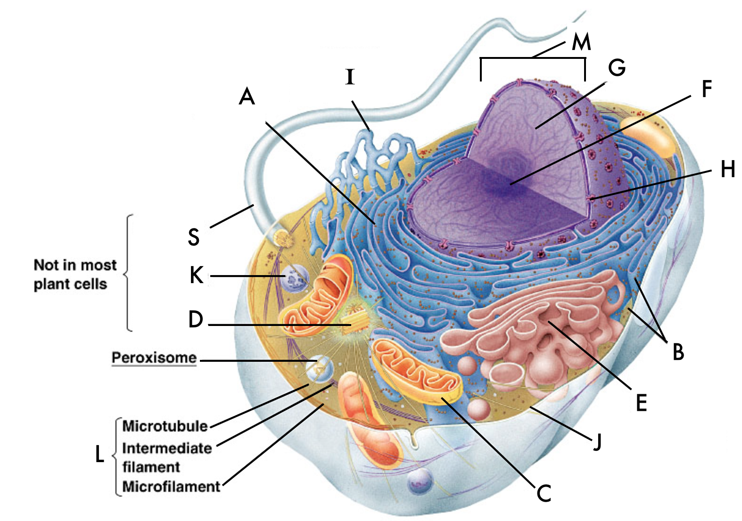
C. Cytoplasm: Use the diagrams above to match the labels to the structures

a. Mitochondria (Letter on the picture _____)
i. What is the function of the mitochondria?

ii. In what type of cells would you expect more mitochondria?

iii. What are the parts of the mitochondria?
iv. Why do many scientists think that mitochondria developed from prokaryotes?

b. Ribosomes (Letter on the picture_____)
i. What is a ribosome and what is its function?

ii. Where are they located?

c. Endoplasmic reticulum (Letter on the picture for Rough ER____, Smooth ER____)
i. What is the function of the endoplasmic reticulum?

ii. What is the difference between rough and smooth ER?

d. Golgi apparatus (Letter on the picture_____)
i. What does the golgi apparatus do?

ii. How can you tell it apart from the endoplasmic reticulum?

e. Lysosome (Letter on the picture_____)
i. What is a lysosome?

ii. What does it contain?

f. Cytoskeleton(Letter on the picture_____)
i. What is the cytoskeleton composed of?

ii. What is the function of the cytoskeleton?
g. Centrioles (Letter on the picture_____)
i. What is the purpose of centrioles?

h. Cilia and Flagella (Letter on the picture_____)
i. What is the difference between cilia and flagella?

i. Nucleus (Letter on the picture_____)
i. What are the functions of each component of the nucleus?
1. nuclear membrane (Letter on the picture_____)

2. chromatin (Letter on the picture_____)

3. nucleolus (Letter on the picture_____)

IV. Unique Features of Plant Cells
- What are the three main structural differences between plant and animal cells?

- Cell Wall (Letter on the picture _____)
  - What is the function of the cell wall?

  - Where is the cell wall located?

  - What is the cell wall made of?

- Vacuole (Letter on the picture_____)
  - What is a vacuole?

  - How do plants use a vacuole?

- Plastids (Letter on the picture_____)
  - What is a plastid?

  - What is the difference between a chloroplast and a chromoplast?

V. Passive Transport
A. Passive Transport
a. What does “semi-permeable” mean?

- What is passive transport?

- What types of molecules can move across the cell membrane?

B. Diffusion
a. What is diffusion?

b. What is a concentration gradient?

c. What are 3 factors that effect the rate of diffusion?

- What is equilibrium?

- Give an example of diffusion.

C. Osmosis
a. What is osmosis?

b. What is the difference between a solute and a solvent?

c. Define the terms in relation to the amount of solute they contain
i. hypertonic

ii. hypotonic

iii. isotonic

d. Which way will the water move in each of the following examples? Label the parts that are hypertonic, hypotonic and isotonic.
20% solute
20% solute
20% solute
60% solute
80% solute
20% solute

________________________ ___________________ ________________________

e. Draw what happens to a blood cell that is placed in each situation:
Hypotonic solution | Hypertonic Solution | Isotonic Solution

f. What is the general rule for the movement of water in regards to hypertonic and hypotonic solutions?

(Part 2)__________________________________________________________________________

g. How do contractile vacuoles help single celled organisms?

h. How do multicellular organisms deal with osmosis?

i. How do plants get water?

j. What happens to plants in hypotonic, isotonic and hypertonic solutions?

k. What is turgor pressure?

l. What is plasmolysis?

m. What happens to animal cells in a hypotonic solution? What’s it called? Give an example.

D. Facilitated Diffusion
a. What is facilitated diffusion?

b. Describe the way a protein transfers a molecule through the cell membrane.

c. What are ion channels? Can ion channels help multiple types of ions move through the membrane?

VI. Active Transport
A. What is active transport? What energy molecule is needed?

B. What are the three types of active transport?

C. Membrane pumps
a. What are membrane pumps?

b. Describe the process (steps) of the sodium-potassium membrane pump action.

c. In the Sodium-Potassium pump, what ion is concentrated on the outside? On the inside?

d. In which direction do sodium and potassium ions diffuse?

D. Endocytosis and Exocytosis
a. What is endocytosis?

i. How is pinocytosis different from phagocytosis?

  - What is Exocytosis?

  - Draw a diagram of endocytosis and exocytosis to and label the inside and outside of the cell.

