Gene | Segments of chromosomes which carry information about specific traits | Hair type
Allele | Different molecular forms of a gene | Curly vs straight hair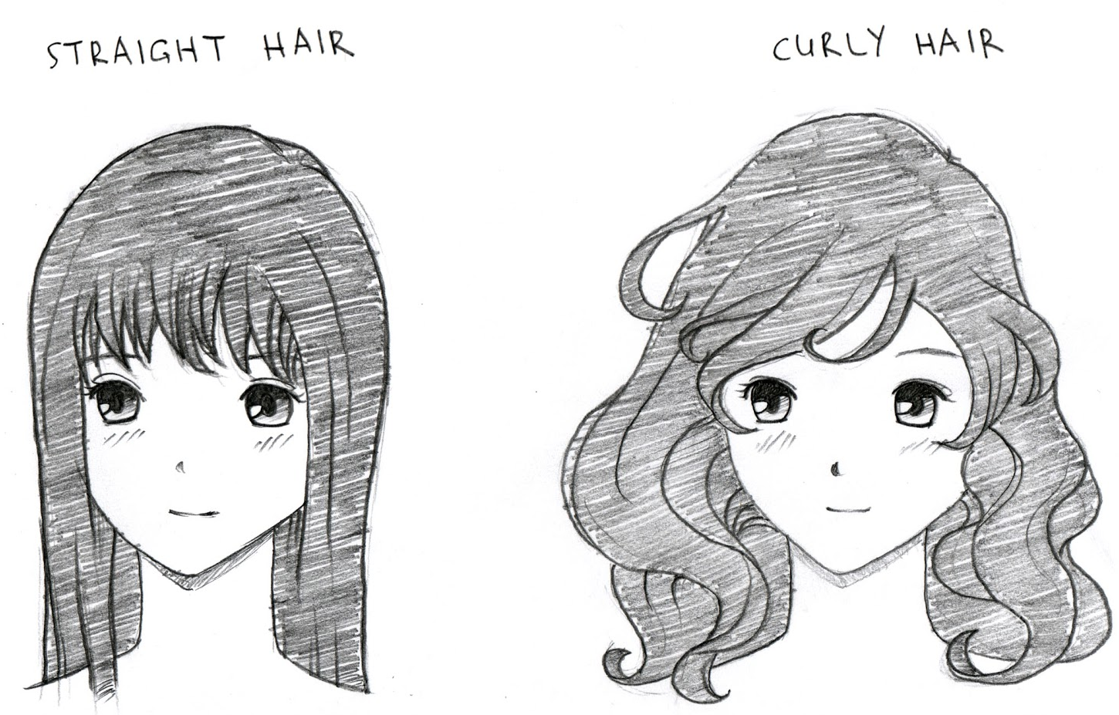
Homozygous (purebred) | Having two identical alleles | AA or aa
Heterozygous (hybrid) | Having two different alleles | Aa
Dominant trait | Will mask recessive trait | AA or Aa
Recessive trait | Can be masked by dominant trait, shows up only with two recessive alleles | aa
Genotype | Refers to particular genes an individual carries | Letter combinations, TT, Tt or tt
Phenotype | Individuals observable traits | Tall or short
Parental generation (P) | Mate to produce first filial generation (F₁) offspring | P x P → F₁
First filial generation (F₁) | Mate to produce second filial generation (F₂) offspring | F₁ x F₁ → F₂
Second filial generation (F₂) | The (inbred) offspring of the first filial generation | F₂
Monohybrid cross | One trait crossed | 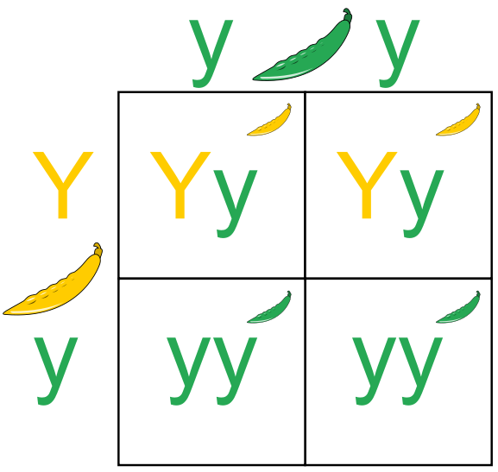
Dihybrid cross | Two traits crossed | 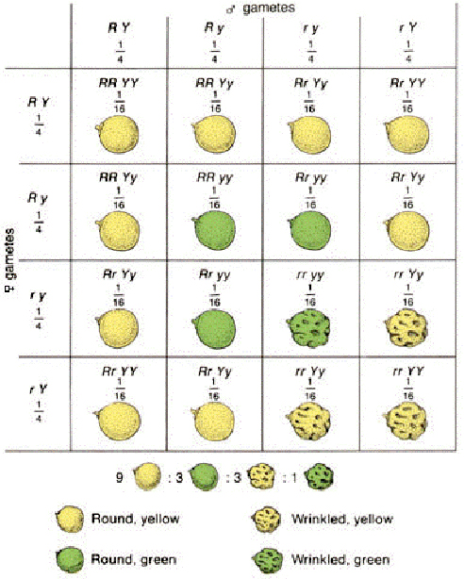
Law of Segregation | Factors (alleles) must randomly separate into gametes | 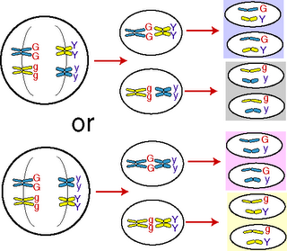
Law of Independent Assortment | A pair of factors (alleles) is separated during gamete formation (each parent contributes one factor for each trait to the offspring) | 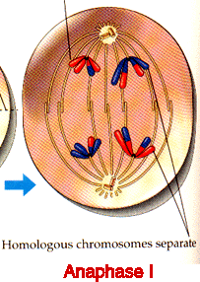
Autosomal Traits | Carried on non-sex chromosomes. Equal chance of males and females getting the trait. | 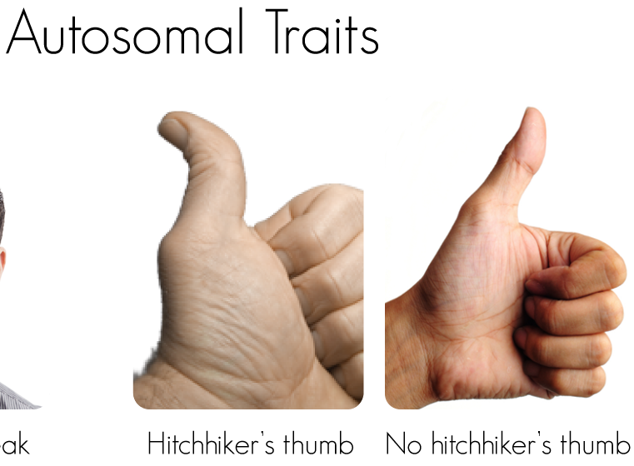
Codominant Traits | Neither trait can mask the other (both show up) | 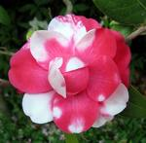
Incomplete Dominant Traits | Neither trait will completely mask the other | 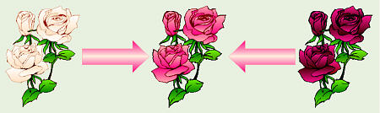
Polygenic Traits | A single trait is influenced by many genes | Eye color 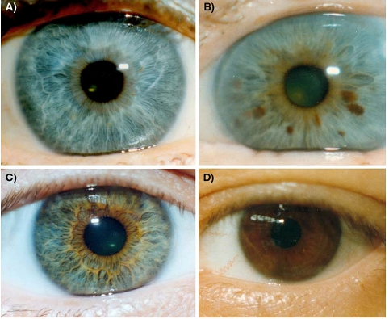
Sex-Linked Traits | Carried on the sex chromosomes (almost exclusively on the X) mostly shows up in males. | 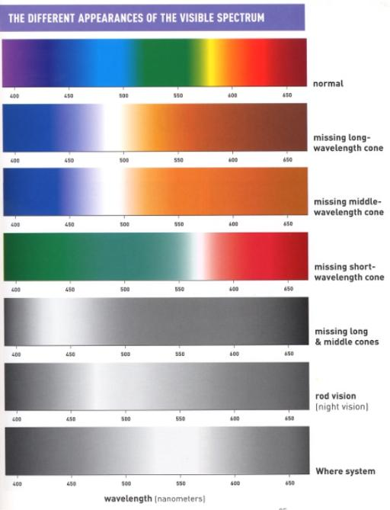colorblindness
Punnett Square | A diagram to help predict the probable distribution of inherited traits in the offspring | 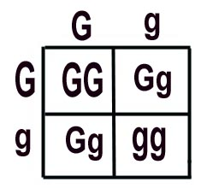
Pedigree | A chart of the genetic history of family over several generations | 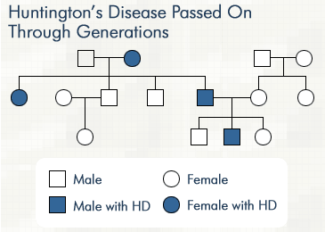
Test Cross | When the unknown individual is crossed with a homozygous recessive individual. If any of the offspring are recessive, then the unknown parent is heterozygous | 